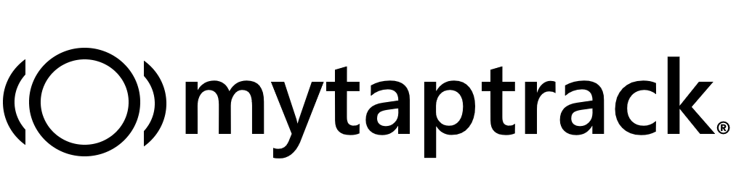

Date: ________________
School: ______________

Dear ________(parent)__________,

mytaptrack is a system we are using at _______(school name)_______ to support diverse learners. The system includes a click-touch button and online dashboard designed to count the moments that shape children with special needs. We use mytaptrack by clicking the button each time we observe a symptom or behavior relevant to a child’s IEP or other educational plan.

mytaptrack was created by the father of son with special needs. He wanted a better, more accurate way for his child’s special needs symptoms and behaviors to be tracked during school hours. We’re excited to be using mytaptrack in our school.

We want you to know that keeping your child’s health care and educational data is our number one priority. The mytaptrack method allows us to track and report required data in a safe way that meets both HIPAA (Health Insurance Portability and Accountability Act) and FERPA (Family Educational Rights and Privacy Act) compliance standards.

This letter serves to inform you that mytaptrack is being used to improve education practices at our school, and to obtain your permission to include your child in the program. Please sign the attached document and return it to us at your earliest convenience.

To learn more about mytaptrack, visit: www.mytaptrack.com

Thanks,
[teacher name signature]
[teacher name print]

[legal document enclosure]

